**Chapter 2: Diode Applications**

Table of Contents

2.2 Load-Line Analysis 2

2.3 Series Diode Configurations 4

2.4 Parallel and Series-Parallel Diode Configurations 5

2.5 AND/OR Gates 6

2.6 Half Wave Rectification 7

2.7 Full Wave Rectifier 8

## 2.2 Load-Line Analysis

Diodes can be analysed using either its actual characteristics or by applying an approximate model for the device. Load-line analysis is done to analyse a diode circuit using its actual characteristics.

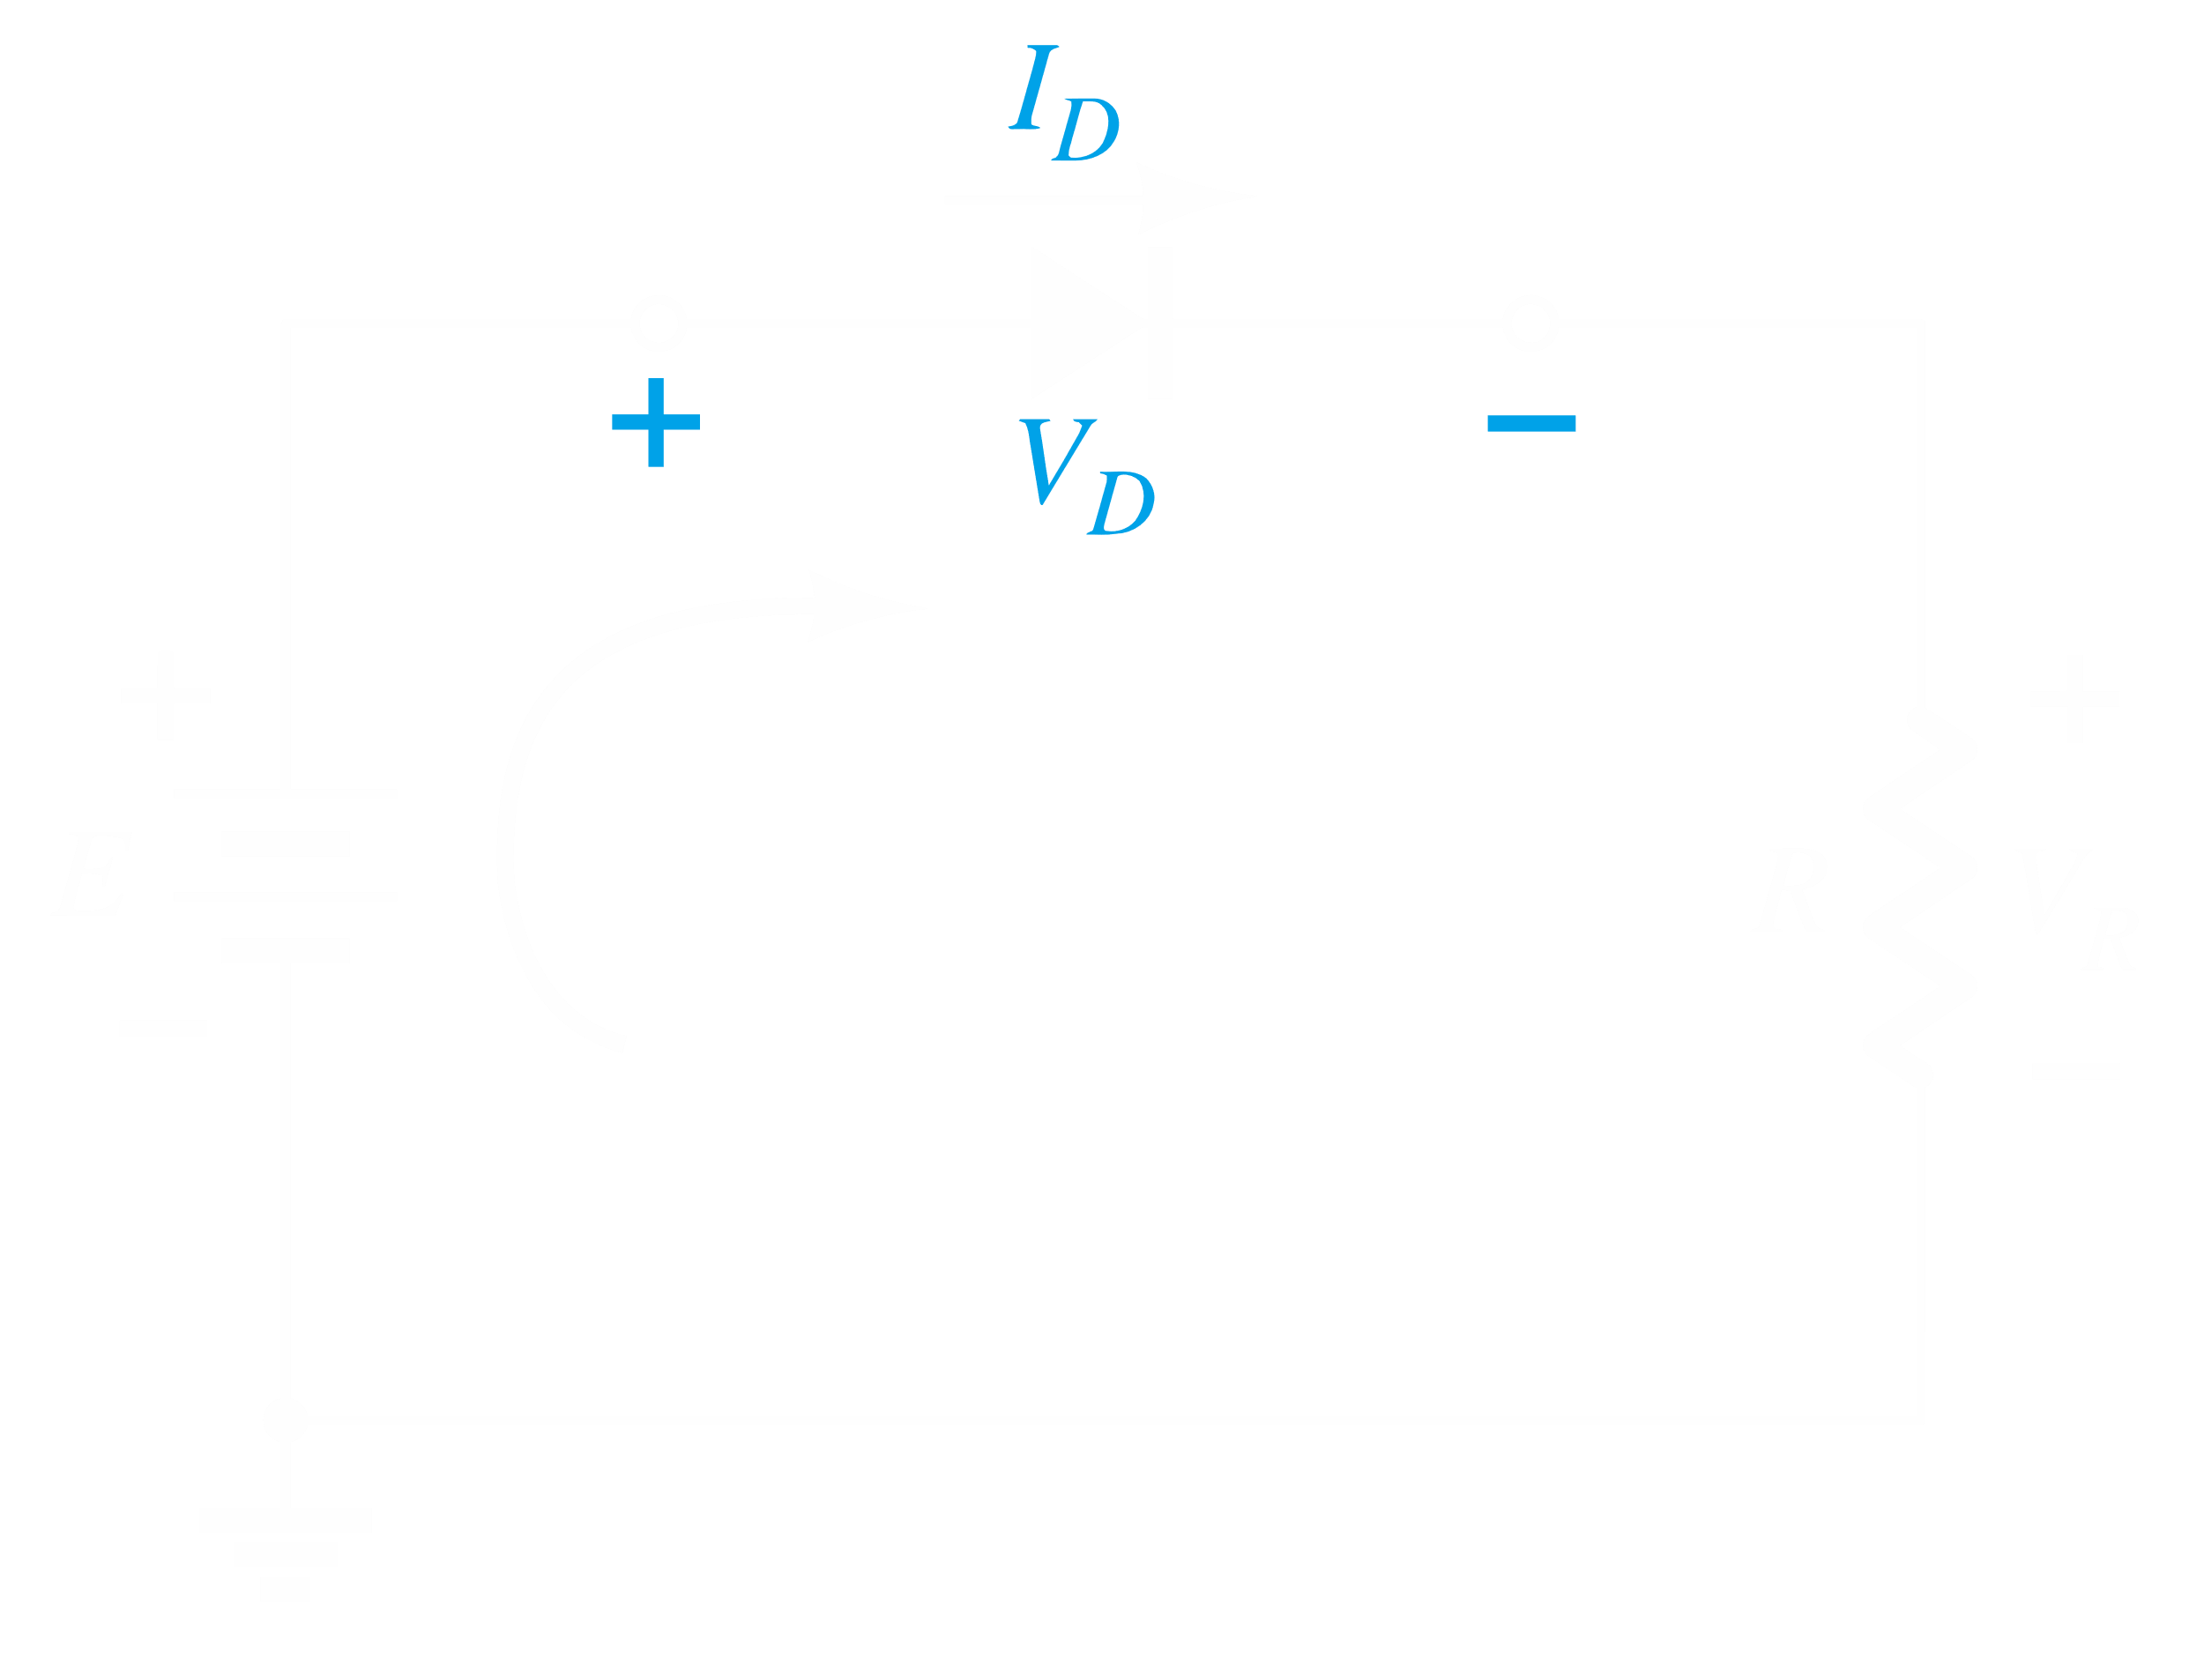

The parameters of the network being used will define a straight line that intercepts the vertical axis at $\frac{E}{R}$. This line is called the load line, since it depends on $R$. Putting this line on the same axis as the characteristic curve of the diode we get:

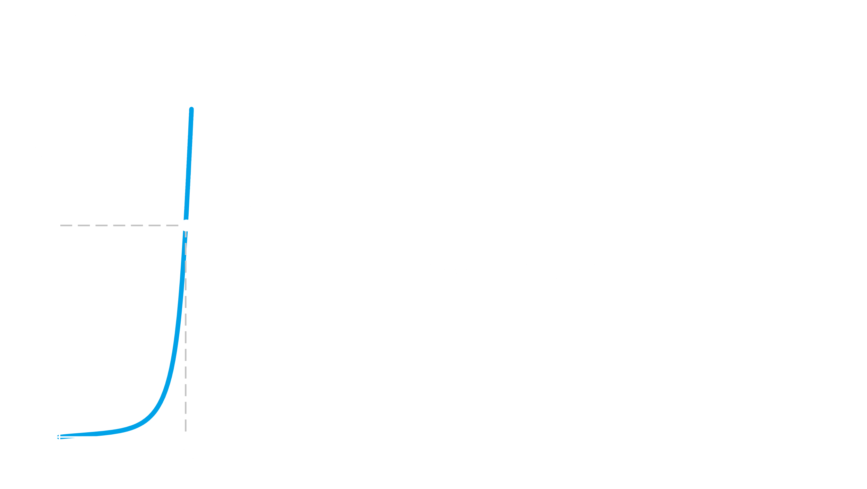

The point at which the load line intersects the curve is known as the Q-point, and this is the optimal operating point. We should attempt to create a circuit that places the Q-point at a linear place of the curve. From here, we can calculate the values of $I_{D}$ and $V_{D}$ for a particular diode in a given circuit.

Consider Example 2.1:

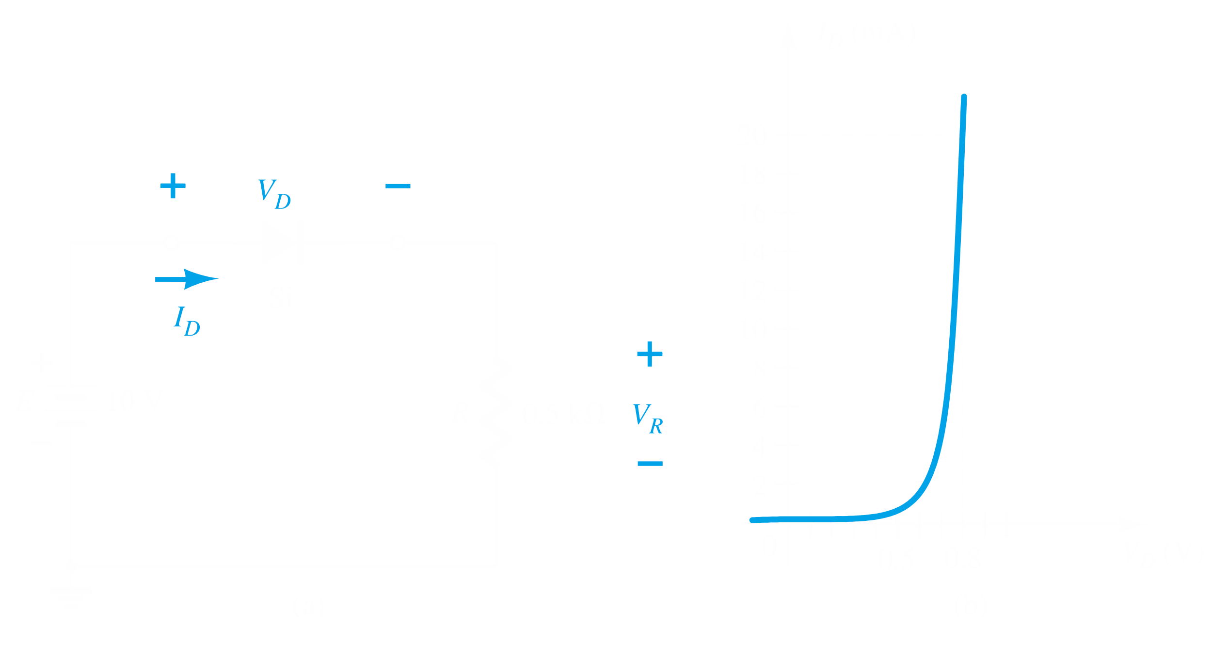

According to Kirchoff’s voltage law, $E=V_{D}+V_{R}=V_{D}+I_{D}R$

If $I_{D}=0$, $V_{D}=10V$. If $V_{D}=0$, $I_{D}=20mA$

If we plot this line over the curve, we get a Q-point at $V_{DQ}=0.78V$, $I_{DQ}=18.5mA$.

From there, $V_{R}=10-0.78=9.22V$

## 2.3 Series Diode Configurations

If the material for the diode is not given, assume that it is Silicon. Si has an operating voltage of $0.7V$. Germanium is an operating voltage of $0.3V$. If any other material is used, the voltage will be given.

Example 2.4

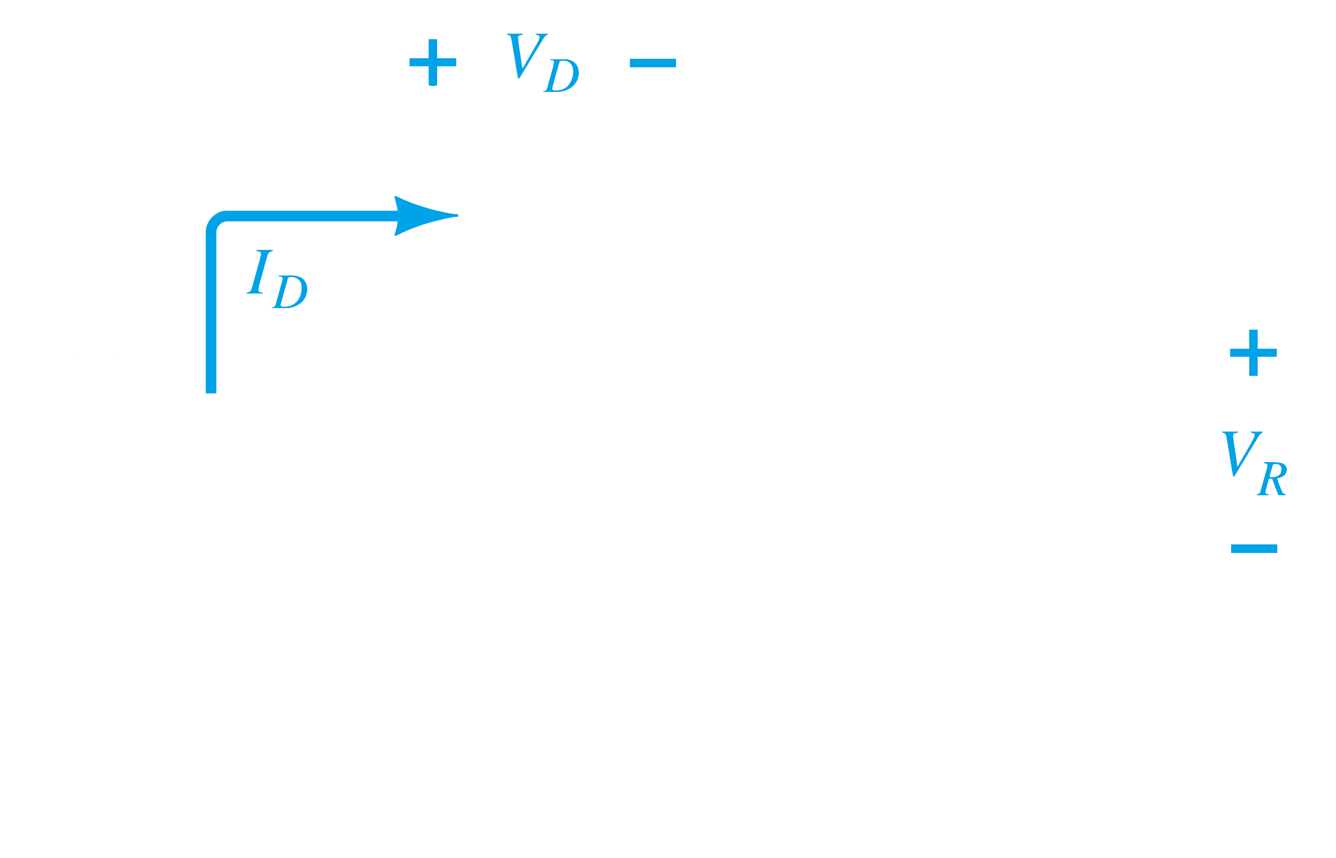

Here, since $E$ is higher than the forward bias voltage of a Silicon diode, the circuit will work.

Since $V_{D}=0.7$, $V_{R}=8-0.7=7.3V$

$$I_{D}=I_{R}=\frac{V_{R}}{R}=\frac{7.3}{2.2}=3.32mA$$

If the diode were flipped, it would act like an open circuit.

Example 2.7

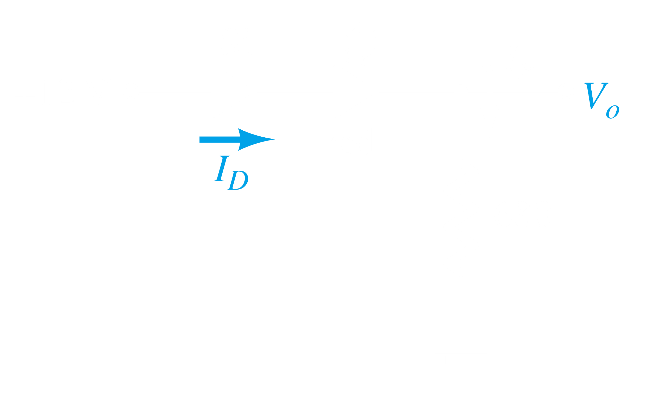

The forward bias voltage of the red LED is given as 1.8V.

Thus, $V_{0}=V_{R}=12-1.8-0.7=9.5V$

$$I_{D}=I_{R}=\frac{9.5}{680}=13.97mA$$

## 2.4 Parallel and Series-Parallel Diode Configurations

Always remember that the voltage drop across a diode is $0.7V$, given that the diode is made of silicon.

Example 2.13

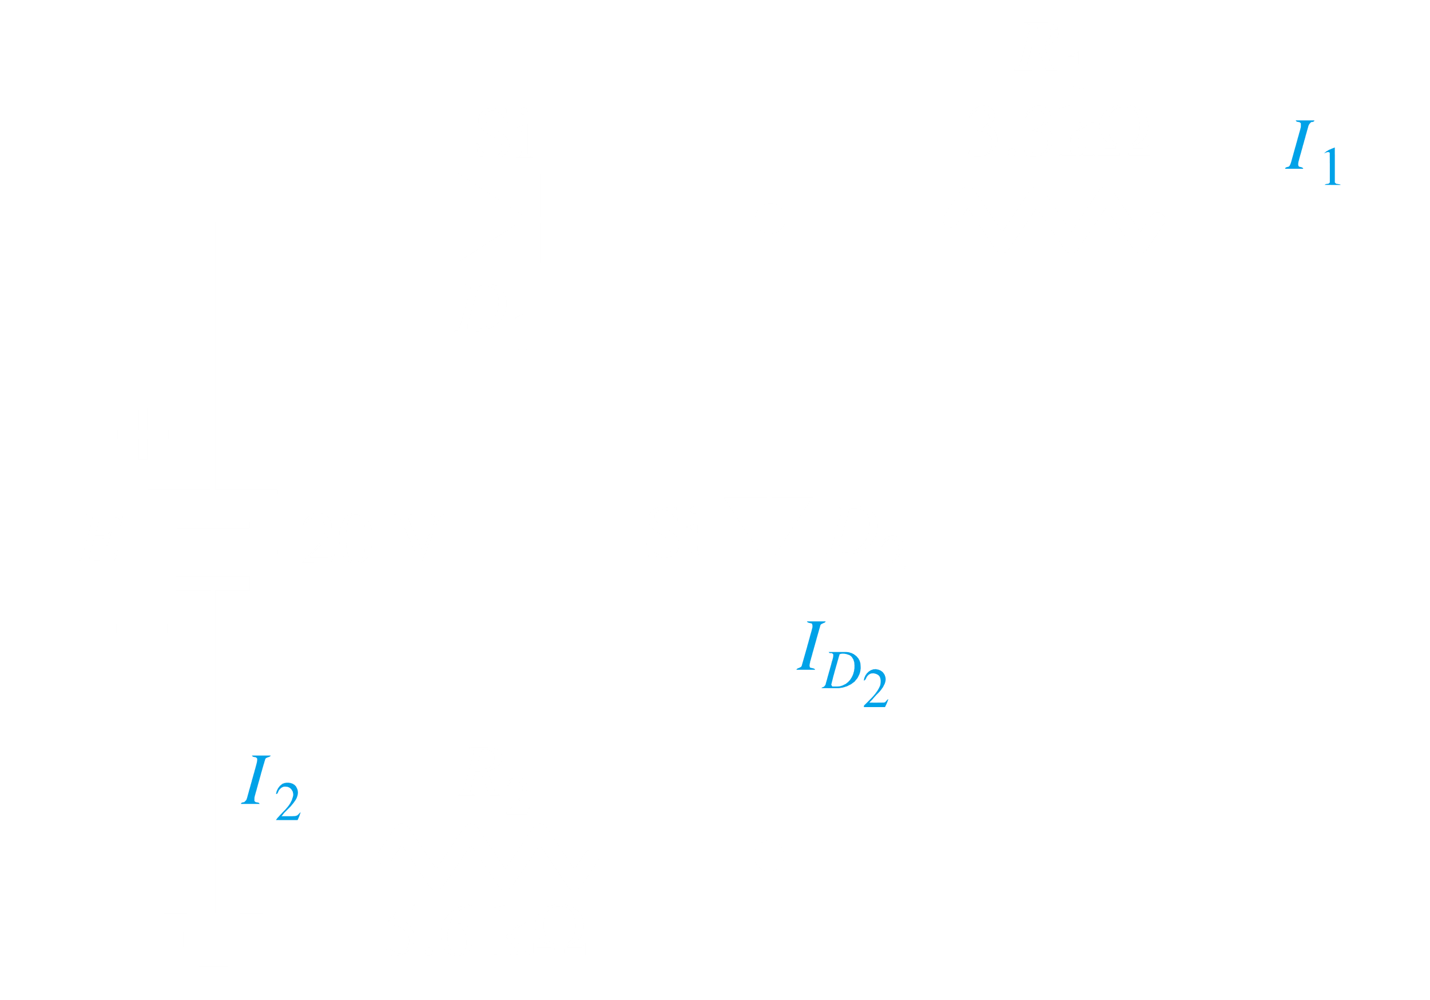

$$V_{D_{2}}=0.7V=I_{1}×3.3$$

$$I_{1}=0.212mA$$

$$I_{2}=\frac{20-0.70-0.70}{5.6}=3.32mA$$

$$I_{D_{2}}=3.32-0.212=3.11mA$$

## 2.5 AND/OR Gates

Example 2.14



This is an example of an OR gate configuration. We assume that each diode only takes away $0.7V$. Thus, after crossing D1, 9.3V are left that are equally sent to $V_{0}$ and $R$. Nothing goes to D2, since it has the incorrect orientation.

Example 2.15

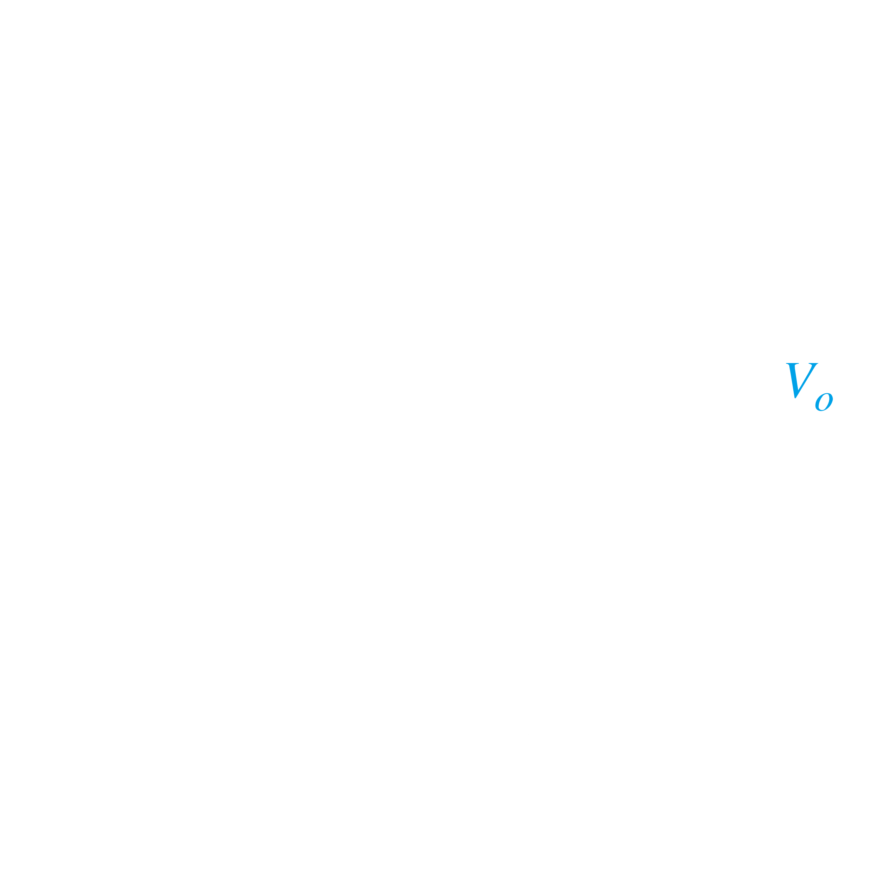

This is the configuration for an AND gate. $E_{1}$ is at the same voltage (or probably higher) than $E$, so no current goes in that direction. $E_{2}$ is at $0V$, so the entirety of the 10 volts is dropped between $E_{2}$ and $E$. We are assuming $D_{2}$ only takes up $0.7V$, so the rest is dropped at $R$. Since $V_{0}$ is a point beyond $R$, it also gets $0.7V$, the same as $D_{2}$. Thus, we consider that $V_{0}$ is at the off state. If both $E_{1}$ and $E_{2}$ had been at $10V$, no voltage would be dropped at $D_{1}$ and $D_{2}$, and whatever voltage was left after crossing $R$ would go to $V_{0}$.

## 2.6 Half Wave Rectification

Since a diode only allows movement of current in one direction, a simple circuit with a diode can create a half-wave rectifier. In this process, one half of the original signal is removed.

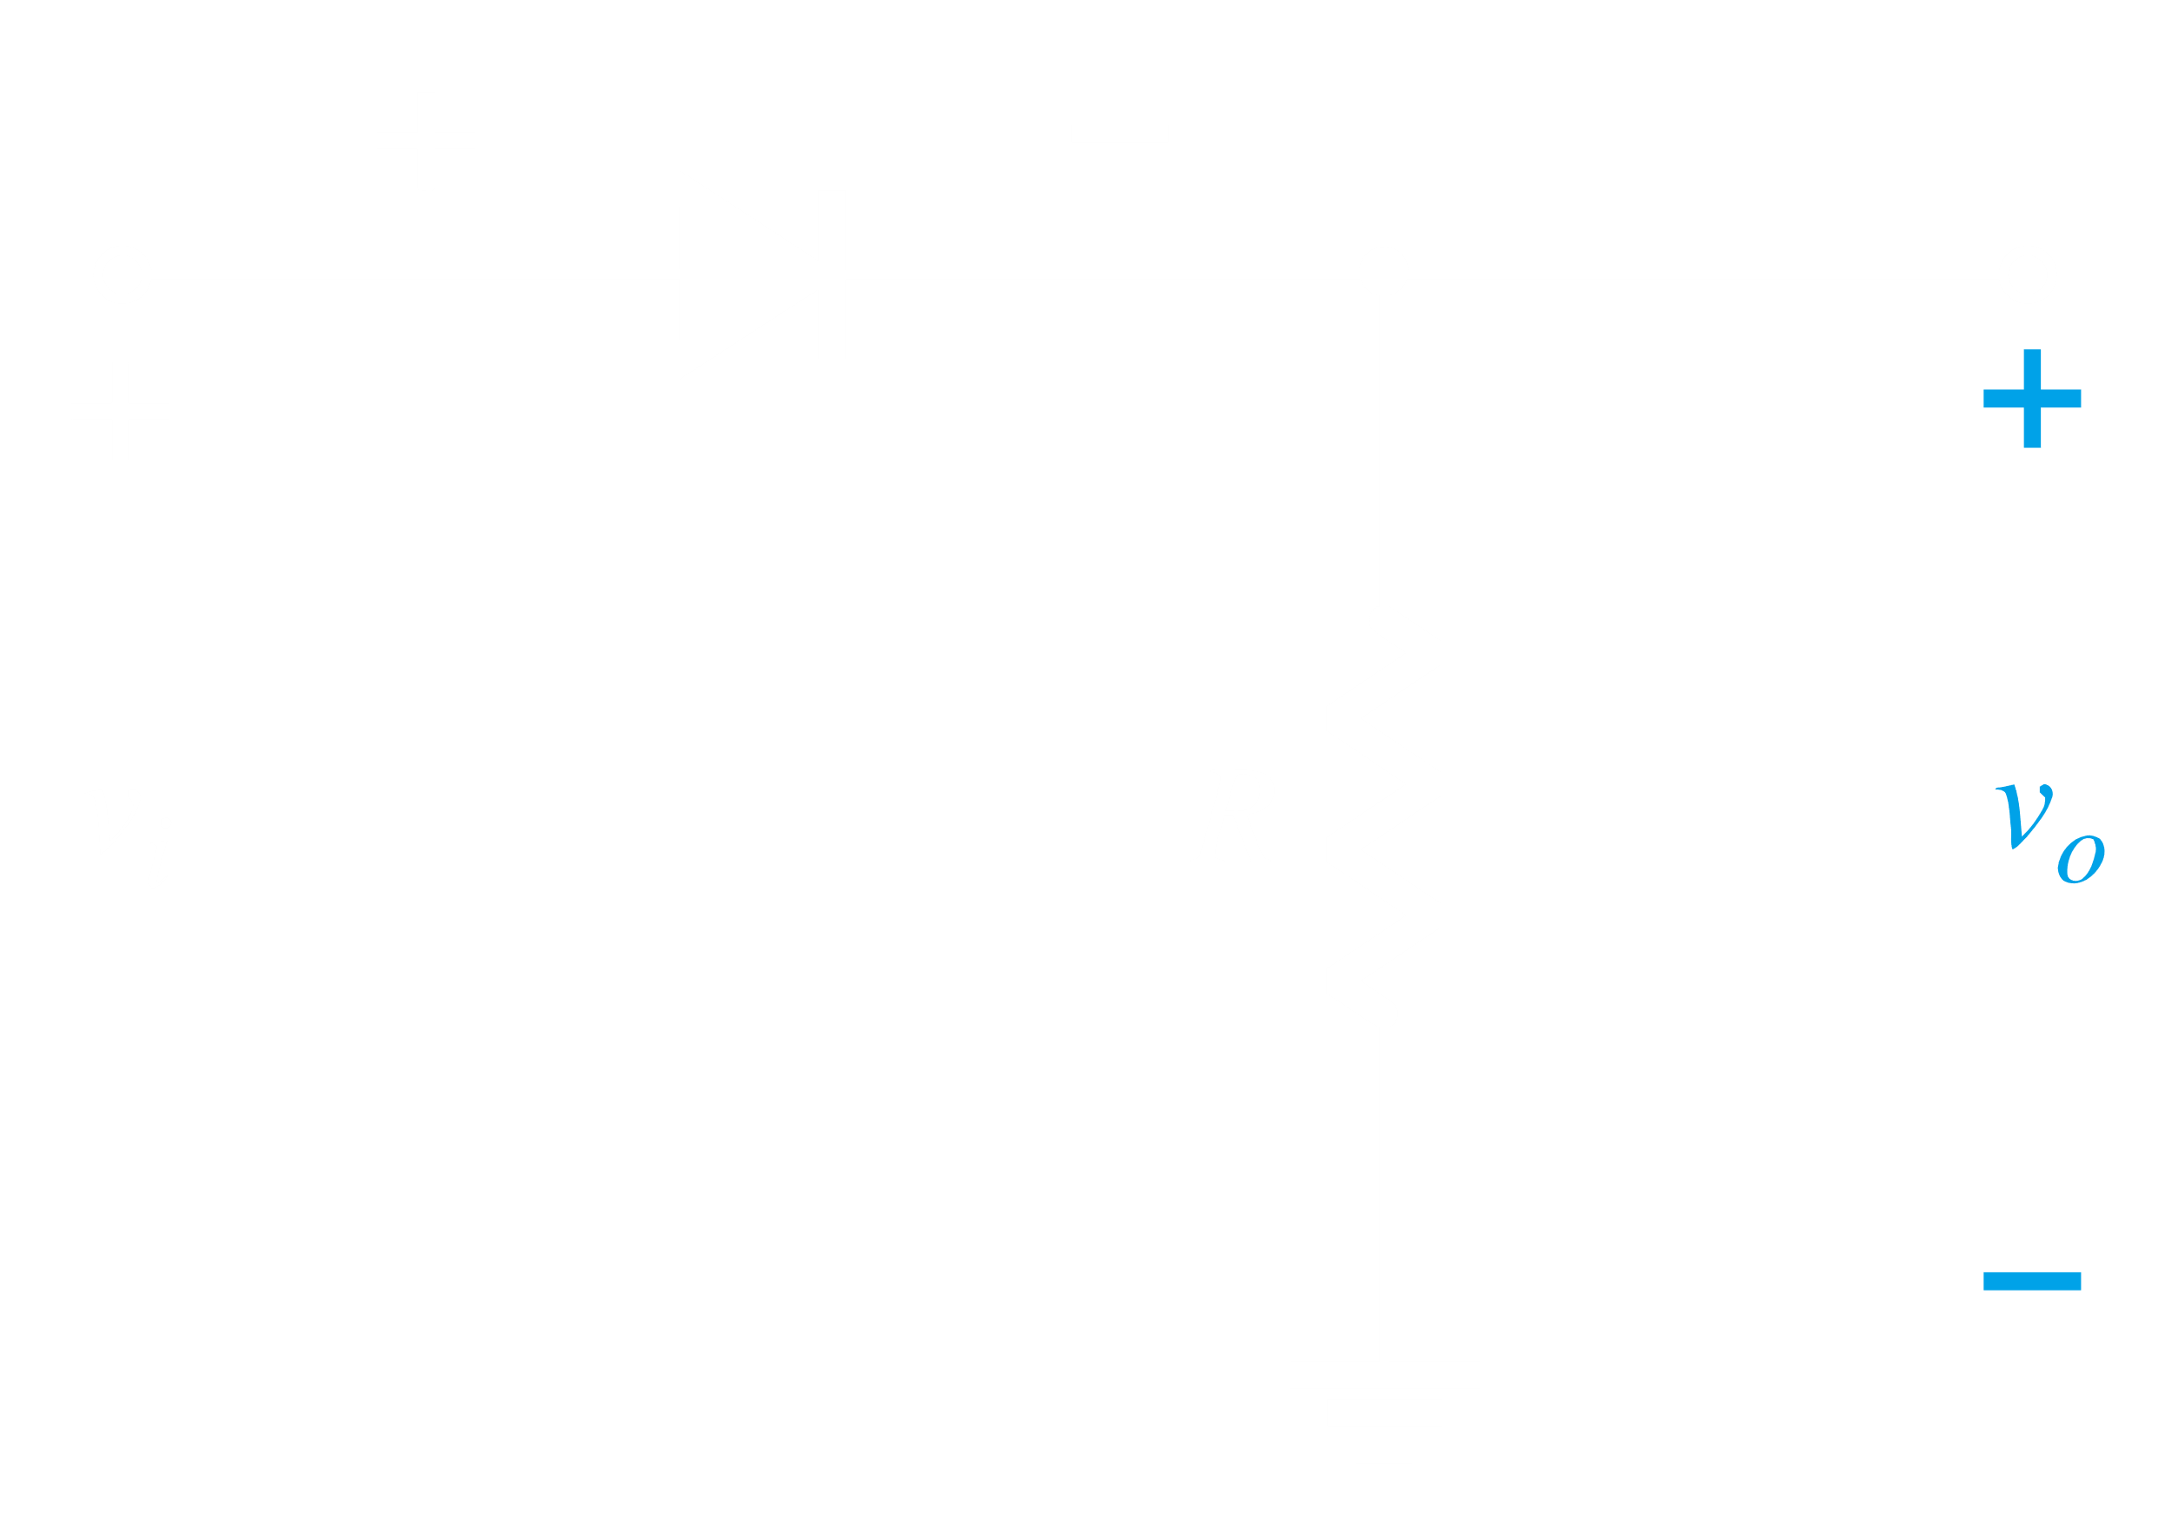

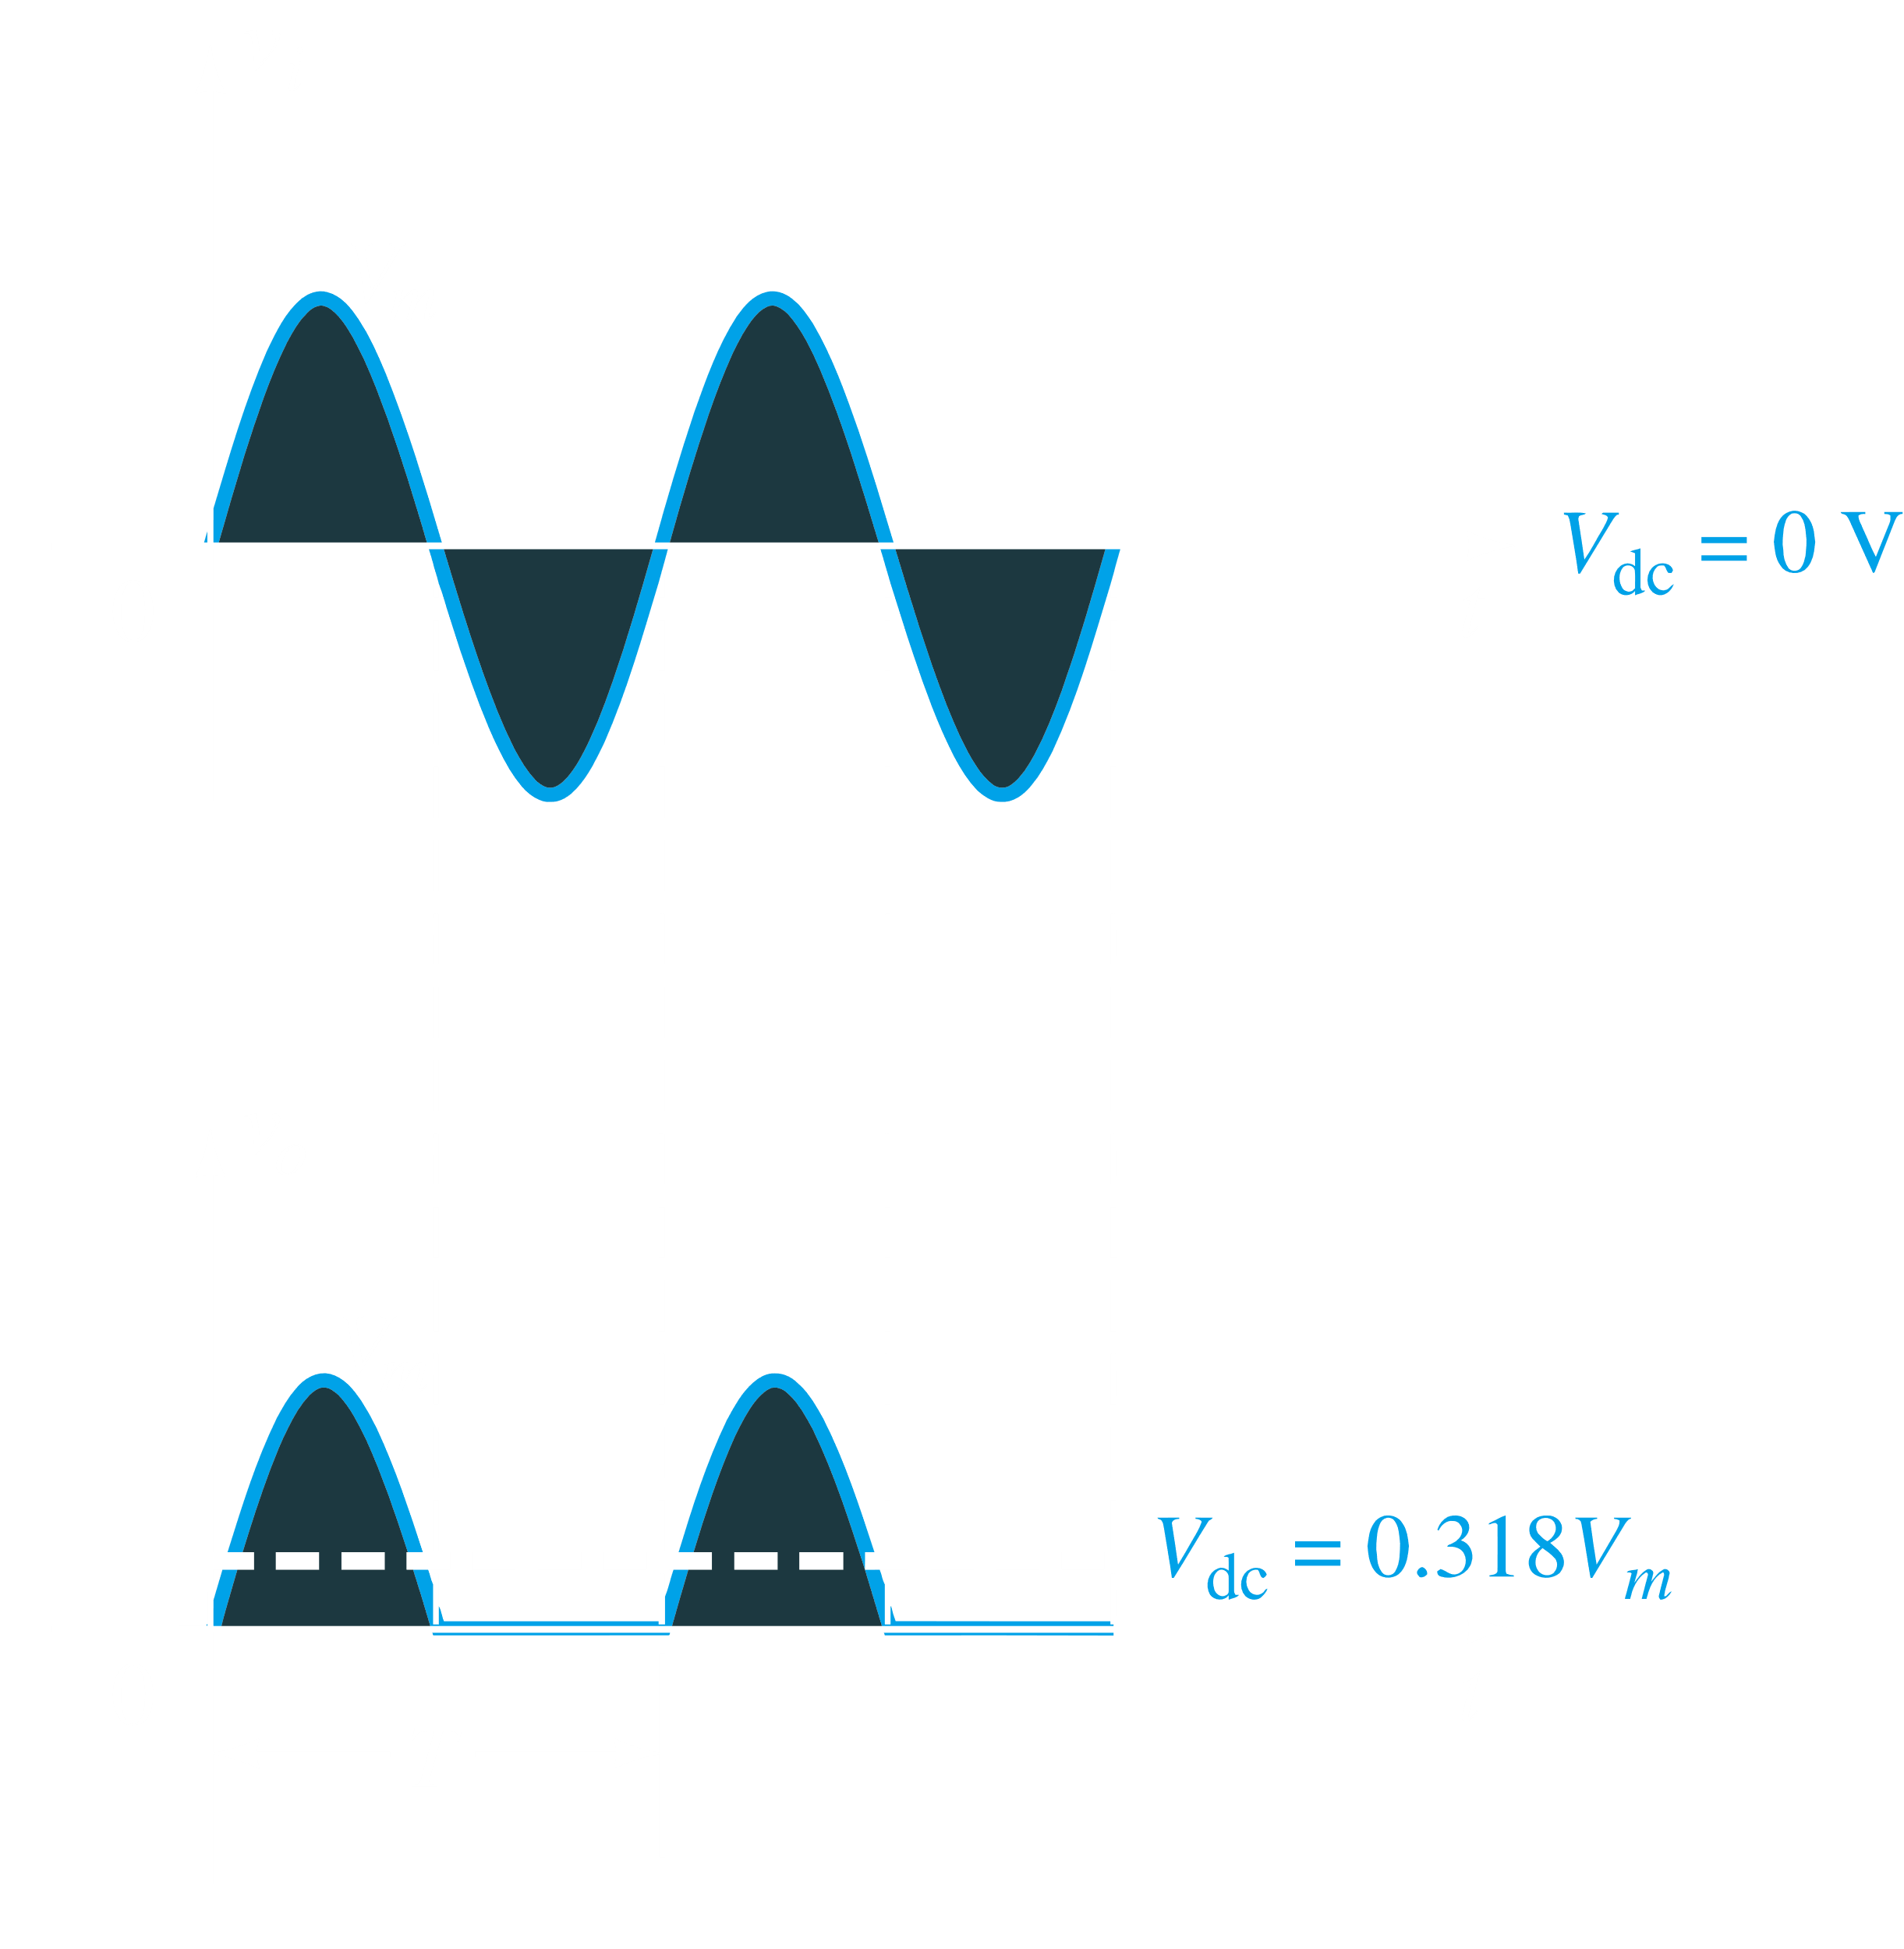

## 2.7 Full Wave Rectifier

To create a full wave rectifier, we must use a bridge network with four diodes.

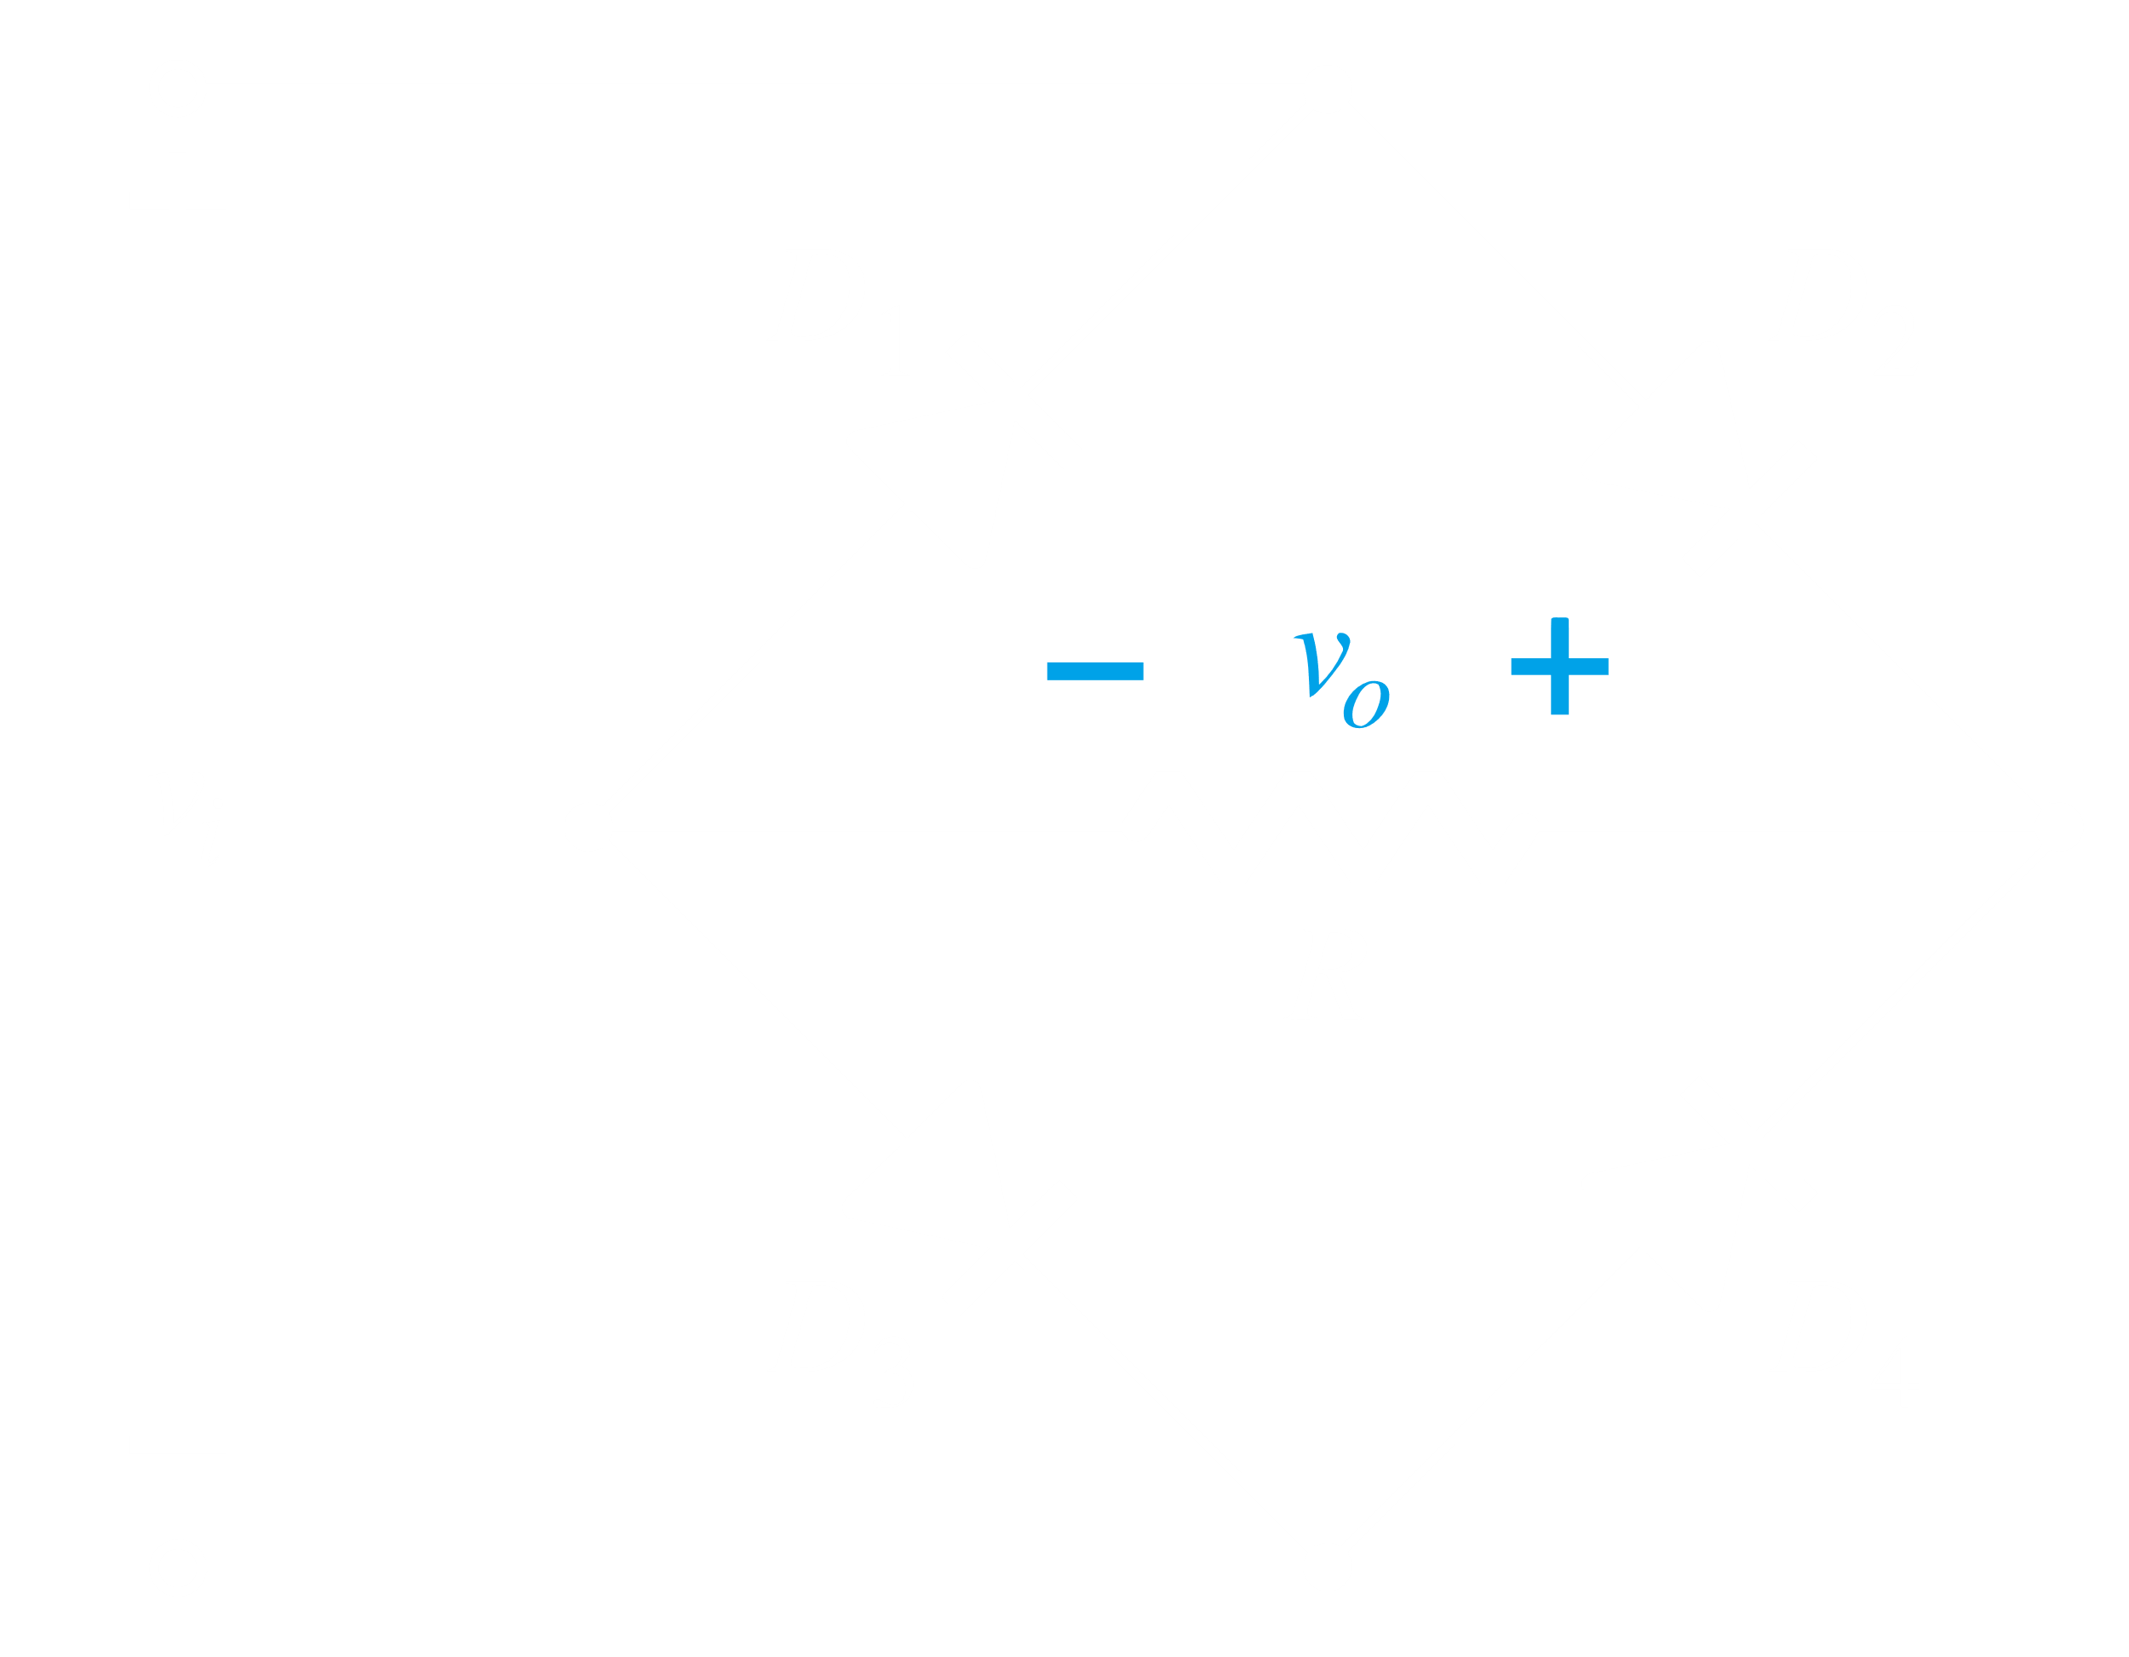

Thus, during the time period in which the voltage is positive, the current flows like this:

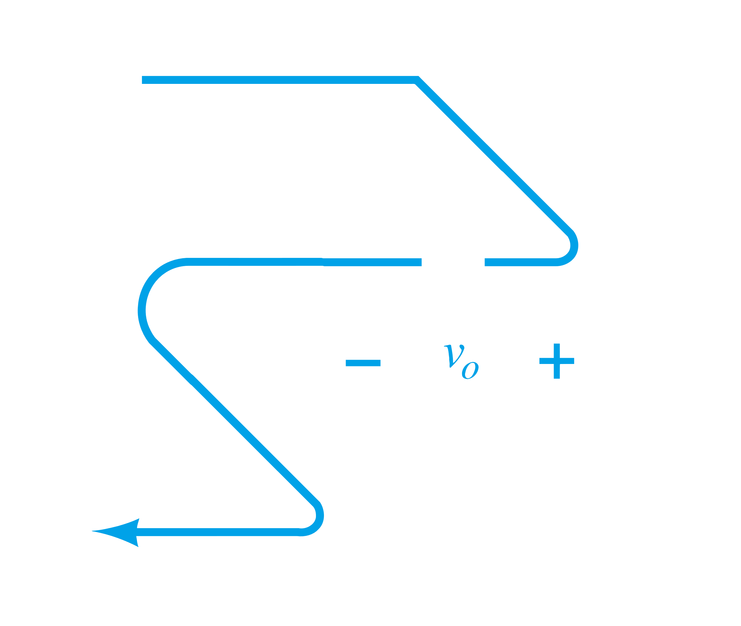

And during the time period for which voltage is negative, the current flows like this:

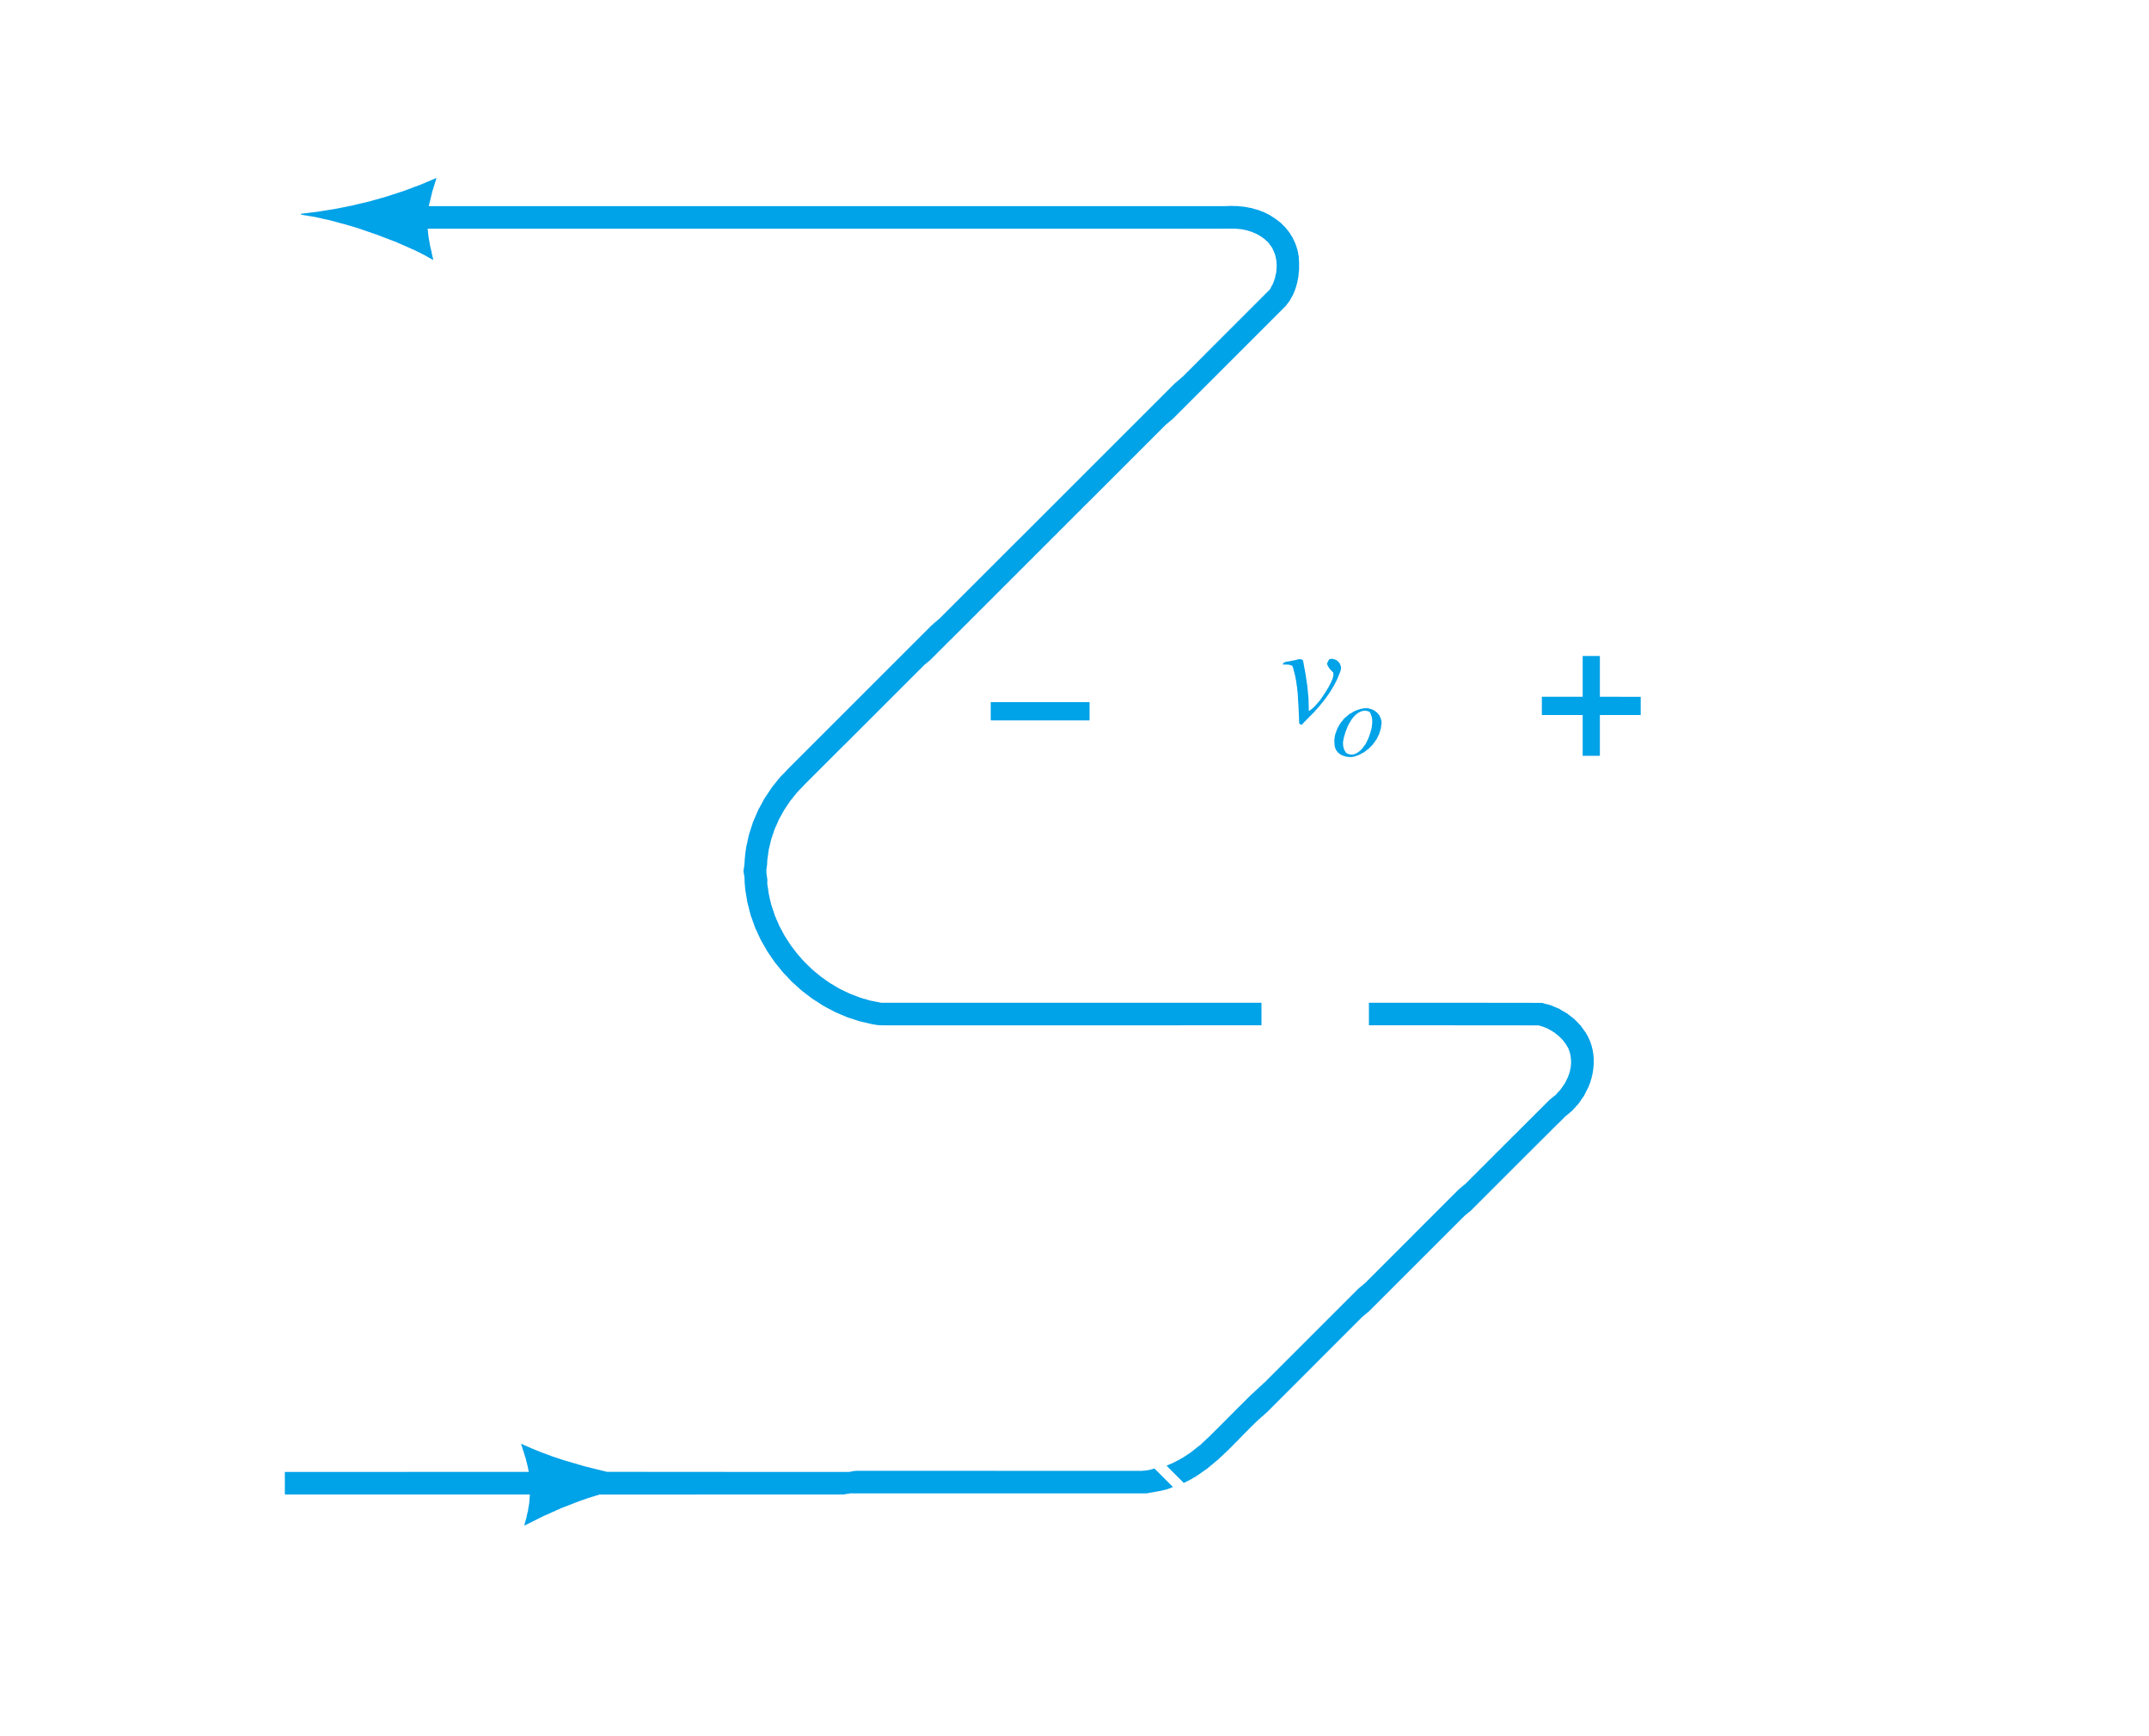

The overall voltage across the resistor is thus:

